

RapidBuild
HTML injections prerequisites

Prepared by: Rapid Solutions and Consulting LLC
Last Updated: December 20, 2016

Table of Contents
Introduction 3
Firefox configuration 4
Oracle EBS Home Page 12

Introduction
Injecting configurations into an Oracle EBS instance via the HTML Oracle screens require some steps to be done first. We are using Firefox and a playback engine to replay in real-time the actions to key and save data to the Oracle HTML forms.
You must follow the steps in this document otherwise the HTML injections will not work as expected.

Firefox configuration
Firefox needs to be setup on the client machine running RapidBuild as per the steps below.

- Download and install Firefox 16.0.2 (only this version of Firefox is supported)
If you change the default installation path of Firefox, then you must change this property in the engine.properties file:

# path to Firefox executable:
FIREFOX_PATH=C:/Program Files/Mozilla Firefox/firefox.exe

- In order for Build to close Firefox browser once the script completes, the following change must be made:
- Type: about:config in the URL prompt (1)
- Type: dom.allow_scripts_to_close_windows in the Filter prompt (2)
- Right-Click on the record and click Toggle to change the value to "true" (3)
- Type: toolkit.startup.max_resumed_crashes in the Filter prompt (2)
- then Double click on that field and set that to “-1” (3)
- Type: browser.sessionstore.resume_from_crash in the Filter prompt (2)
- then Double click on that field and set that to "false" (3)

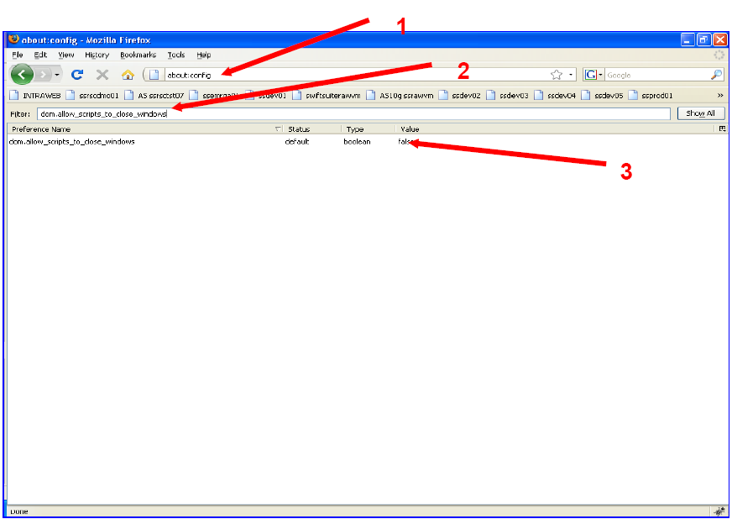

- Make sure that you disable product updates. Firefox 16.0.2 is considered “out of date,” and thus Firefox will helpfully try to upgrade it unless you tell it not to. Build, alas, requires this version of Firefox.

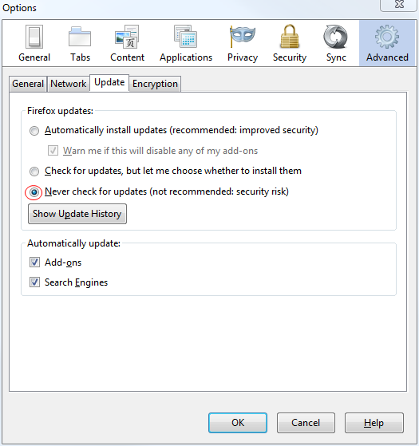

- Create the following new preference in “about:config” dom.allow_XUL_XBL_for_file of type: boolean and set the value to “true”.
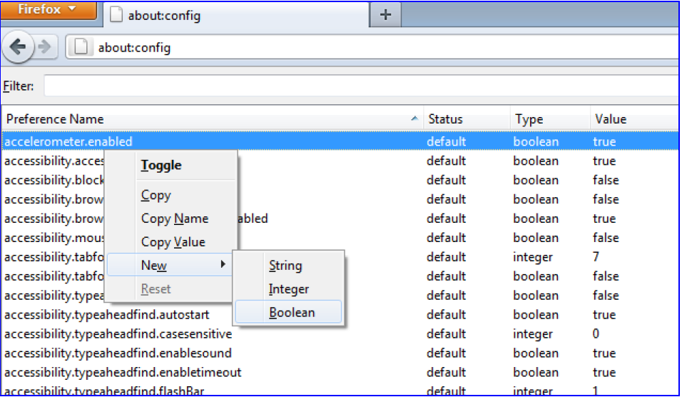

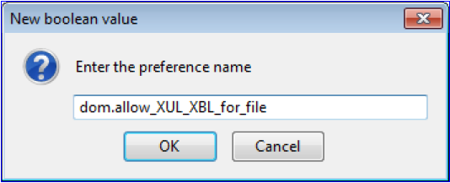

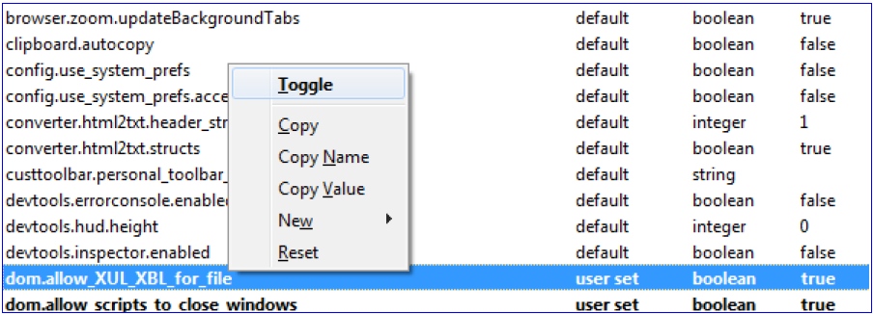

- In “Tools” → ”Options” uncheck the box “Open new windows in a new tab instead”, then click OK.
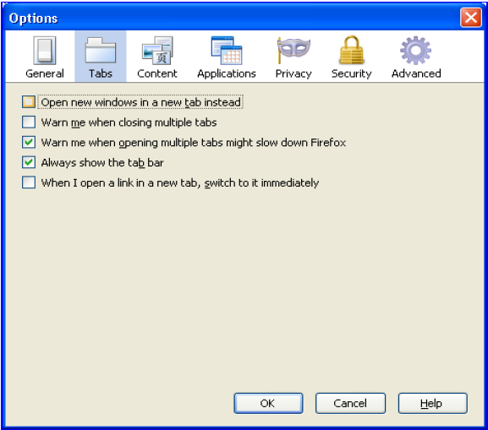
If the following pop-up occurs when Firefox starts, then check the box: “Remember this decision” and click on the button “Allow”

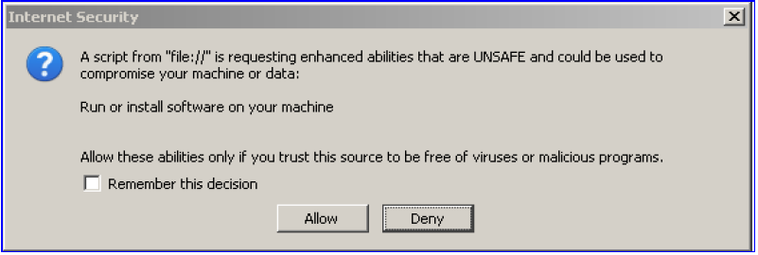
If that popup still reoccur for the next script, then do the following:

- Close Firefox.
- Open the Windows Explorer (Example: clicking on My Computer icon on your desktop).
- Copy and paste or type this address path below into the adders bar then press Enter.
“%appdata%\Mozilla\Firefox\Profiles”
- You should see the Firefox profile folder as example screenshots below.
Note: The path in the address bar is varies by operating system and account name. The folder name may be not exactly same as it is randomly generated by Firefox.

Windows XP
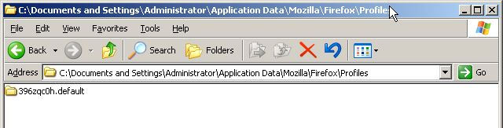
Windows 7
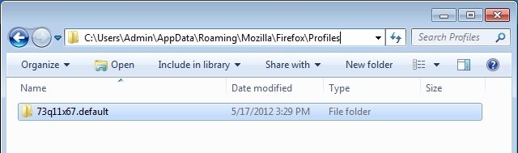

- Enter into the folder open the “prefs.js” file as shown below with the text editor.
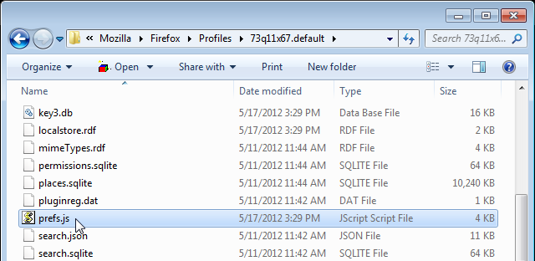
- Add the following lines belower into the folder open the “prefs.js” file as show below with text editor.

user_pref("capability.principal.codebase.p0.granted", "UniversalXPConnect");
user_pref("capability.principal.codebase.p0.id", "file:///<PATH-TO-MY-DOCUMENTS>/swiftbuild-output/temp/startup.xul");
user_pref("capability.principal.codebase.p0.subjectName", "");

- Make sure to replace <PATH_TO_MY_DOCUMENTS> by instruction below.
Make sure to use the “/” character and not “\” in the above path.
Save and restart the injection.

To verify <PATH_TO_MY_DOCUMENTS>
- Open the Windows Explorer.
- Place line below on Address Bar as picture below and then press Enter.
For Window XP : %USERPROFILE%/My Documents
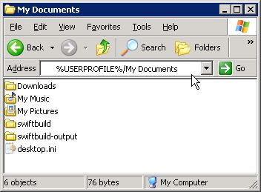

For Window 7 and Vista : %USERPROFILE%/Documents

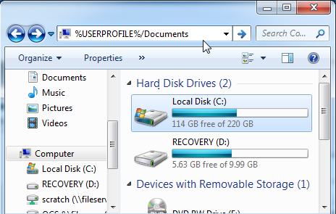

- Then you will see your <PATH_TO_MY_DOCUMENTS> in Address Bar and you should find swiftbuild-output folder in this location as you can see an example in the picture below. Your path might not the same as an example so please make to use your path and change the “\” character to “/” .

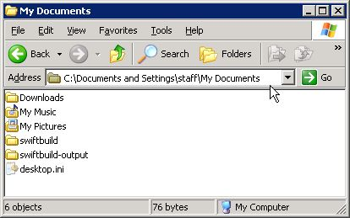
From an Example picture for Window XP the 3 line above should like below.

user_pref("capability.principal.codebase.p0.granted", "UniversalXPConnect");
user_pref("capability.principal.codebase.p0.id", "file:///C:/Documents and Settings/staff/My Documents/swiftbuild-output/temp/startup.xul");
user_pref("capability.principal.codebase.p0.subjectName", "");

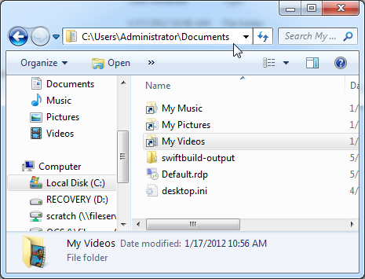
From an Example picture for Window 7 and Vista the 3 line above should like below.

user_pref("capability.principal.codebase.p0.granted", "UniversalXPConnect");
user_pref("capability.principal.codebase.p0.id", "file:///C:/Users/Administrator/Documents/
swiftbuild-output/temp/startup.xul");
user_pref("capability.principal.codebase.p0.subjectName", "");

Oracle EBS Home Page
In Oracle EBS R12.1.3 and above, the home page navigator layout has changed by default. However RapidBuild functions only with the old style navigator. So you need to follow the steps below to set the Home page to the old navigator layout for the Oracle user that you will use for injections purposes.
Not doing so will result of the HTML injections stopping after login at the home page when selecting the responsibility. (RapidBuild does not work with the drop-down menu tree of the new navigator layout)

Default Navigator layout in R12.1.3 (new format)

Old Navigator layout

Steps:
- Open the following form “System Administrator” → “Define Profile Options”.
- Query the User Profile Name: “FND: Disable Configurable Home Page”.
- Select the boxes at the User level and User access as per the screenshot below.
- Save the form.

- Open the form “System Administrator” → “Profile” → “System”.
- Select the user that you are going to use for injections purposes. (In our example, we are using CONSULT).
- Query the Profile: “FND: Disable Configurable Home Page”.

- Make sure False is selected at the site level and True is selected at the user level.
- Save the form.

